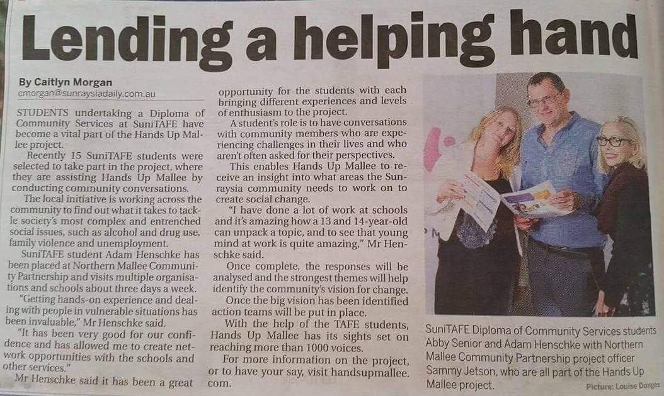
Sunraysia Daily, 23rd May 2017

