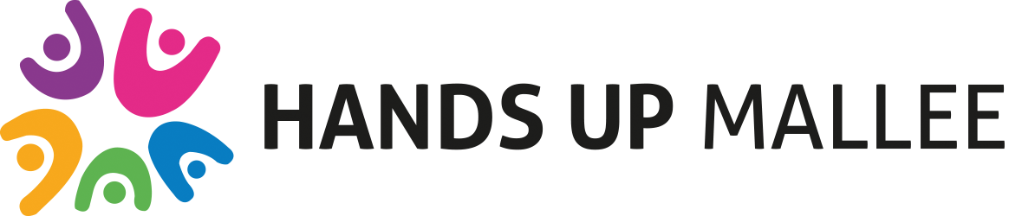

Media Release
TAFE students capture the voices of our community

Local initiative, Hands Up Mallee is working all across the community to find out what it takes to tackle society’s most complex and entrenched social issues, such as alcohol and drug use, family violence and unemployment.

The initiative depends on forming relationships between sectors who don’t usually work together and doing things differently. To ensure Hands Up Mallee gets its priorities right, they are consulting far and wide through a ‘Community Conversations’ process supported by a kit, guide and survey which can be found on the Hands Up Mallee website.

http://www.handsupmallee.com/

15 SuniTAFE Diploma of Community Services students are assisting Hands Up Mallee by conducting community conversations. The students are placed at various organisations throughout Mildura including Mallee Accommodation and Support Services, Mallee Family Care, Chaffey Secondary College, Northern Mallee Community Partnership, Centacare, Sunraysia Community Health Services, FLO Connect, Mildura Senior College and Mallee Domestic Violence Service.

The students’ role is to focus on holding conversations with community members who are experiencing challenges in their lives, and who aren’t often asked for their perspectives. It is absolutely critical that Hands Up Mallee hears from people who are living with complex issues, so that they can get an insight into what areas our community needs to work on first to create social change.

Abby Senior, a student placed with the Northern Mallee Community Partnership, said “Having the opportunity to hold conversations is a valuable learning experience for us as students and this is helping us to really understand our communities."

Working with TAFE students is a win-win for all involved. The students are gaining experience in working with our community members and Hands Up Mallee are receiving invaluable feedback and contribution towards the initiative.

With the help of the TAFE students, HUM has its sights set on reaching over 1000 voices, but to do this, we need your help.

No matter who you are, Hands Up Mallee needs to hear your aspirations, concerns and ideas so that together we can create a plan to make our community an even better place for everyone.

If you would like to get involved in Hands Up Mallee or contribute to the conversation, please visit www.handsupmallee.com

ENDS
Photo opportunity available with students if requested

